**Data Visualization**

**(Type of Charts)**

Python script that demonstrates how to create various types of graphs and charts for data visualization using popular libraries like Matplotlib, Seaborn, and Plotly. These libraries offer a variety of plotting functions for different types of data visualization.

**1. Line Chart**

import matplotlib.pyplot as plt

# Sample data

x = [1, 2, 3, 4, 5]

y = [10, 20, 25, 30, 35]

# Create line chart

plt.plot(x, y)

plt.title("Line Chart")

plt.xlabel("X-axis")



plt.ylabel("Y-axis")

plt.show()

**2. Bar Chart**

import matplotlib.pyplot as plt

# Sample data

categories = ['A', 'B', 'C', 'D']

values = [10, 20, 15, 25]

# Create bar chart

plt.bar(categories, values)

plt.title("Bar Chart")

plt.xlabel("Categories")

plt.ylabel("Values")

plt.show()

**3. Histogram**

import matplotlib.pyplot as plt

# Sample data

data = [1, 2, 2, 3, 3, 3, 4, 4, 4, 4, 5, 5, 5, 5, 5]

# Create histogram

plt.hist(data, bins=5, edgecolor='black')

plt.title("Histogram")

plt.xlabel("Data Bins")

plt.ylabel("Frequency")

plt.show()

**4. Scatter Plot**

import matplotlib.pyplot as plt

# Sample data

x = [1, 2, 3, 4, 5]

y = [5, 15, 10, 20, 25]

# Create scatter plot

plt.scatter(x, y)

plt.title("Scatter Plot")

plt.xlabel("X-axis")

plt.ylabel("Y-axis")

plt.show()

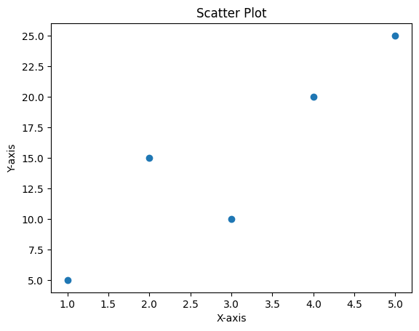

**5. Pie Chart**

import matplotlib.pyplot as plt

# Sample data

Country = ['USA', 'INDIA', 'CHINA', 'UK']

Population = [30, 145, 140, 25]

# Create pie chart

plt.pie(Population, labels= Country)

plt.title("Pie Chart")

plt.show()

**6. Box Plot (with Seaborn)**

import seaborn as sns

import matplotlib.pyplot as plt

# Sample data

data = [10, 20, 25, 30, 35, 40, 50, 60, 70, 80]

# Create box plot

sns.boxplot(data=data)

plt.title("Box Plot")

plt.show()

**7. Heatmap (with Seaborn)**

import seaborn as sns

import numpy as np

import matplotlib.pyplot as plt

# Sample data

data = np.random.rand(10, 10)

# Create heatmap

sns.heatmap(data, annot=True, cmap='coolwarm')

plt.title("Heatmap")

plt.show()

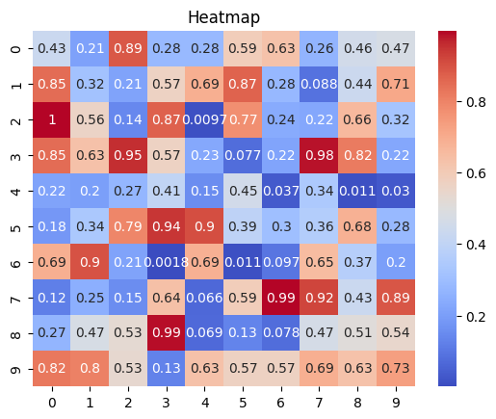

**8. Violin Plot (with Seaborn)**

import seaborn as sns

import matplotlib.pyplot as plt

# Sample data

data = sns.load_dataset("iris")

# Create violin plot

sns.violinplot(x="species", y="sepal_length", data=data)

plt.title("Violin Plot")

plt.show()

**9. Pair Plot (with Seaborn)**

import seaborn as sns

import matplotlib.pyplot as plt

# Sample data

data = sns.load_dataset("iris")

# Create pair plot

sns.pairplot(data, hue="species")

plt.title("Pair Plot")

plt.show()

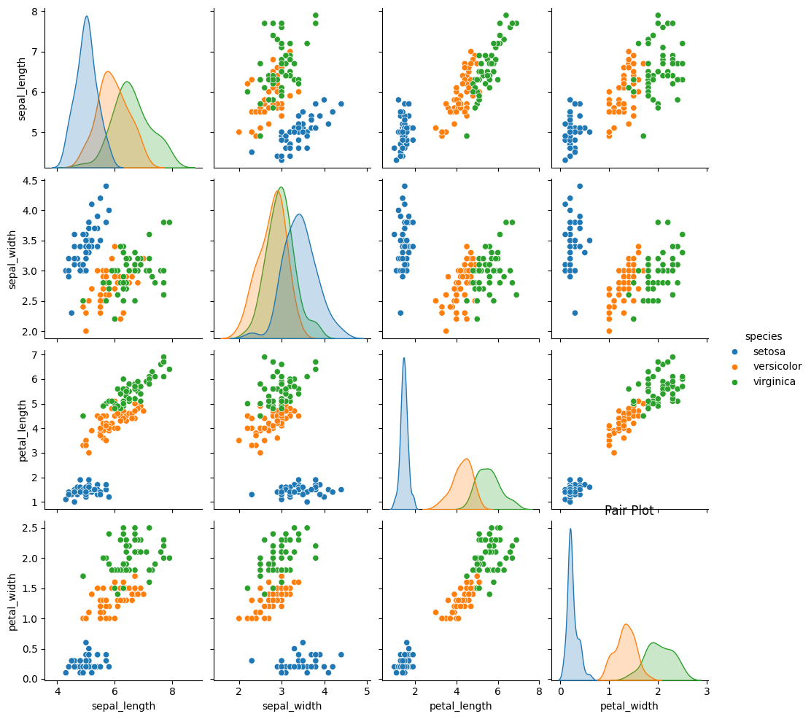

**10. 3D Scatter Plot (with Plotly)**

import plotly.express as px

# Sample data

df = px.data.iris()

# Create 3D scatter plot

fig = px.scatter_3d(df, x='sepal_length', y='sepal_width', z='petal_length', color='species')

fig.update_layout(title="3D Scatter Plot")

fig.show()

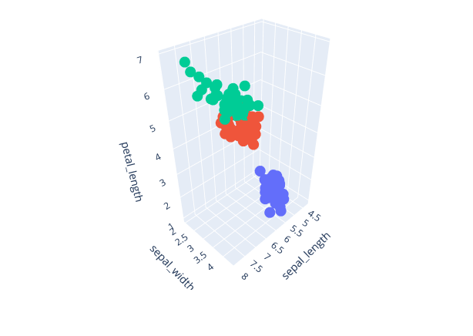

**11. Time Series Plot**

import matplotlib.pyplot as plt

import pandas as pd

# Sample data

dates = pd.date_range('20230101', periods=10)

values = [5, 10, 8, 12, 15, 13, 18, 20, 22, 25]

# Create time series plot

plt.plot(dates, values)

plt.title("Time Series Plot")

plt.xlabel("Date")

plt.ylabel("Values")

plt.show()

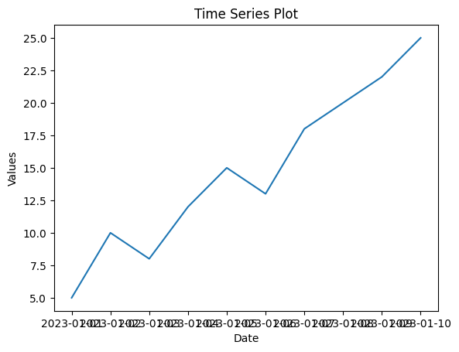

**12. Area Chart**

import matplotlib.pyplot as plt

# Sample data

x = [1, 2, 3, 4, 5]

y1 = [10, 20, 25, 30, 35]

y2 = [5, 15, 20, 25, 30]

# Create area chart

plt.fill_between(x, y1, color="skyblue", alpha=0.4)

plt.fill_between(x, y2, color="orange", alpha=0.6)

plt.title("Area Chart")

plt.xlabel("X-axis")

plt.ylabel("Y-axis")

plt.show()

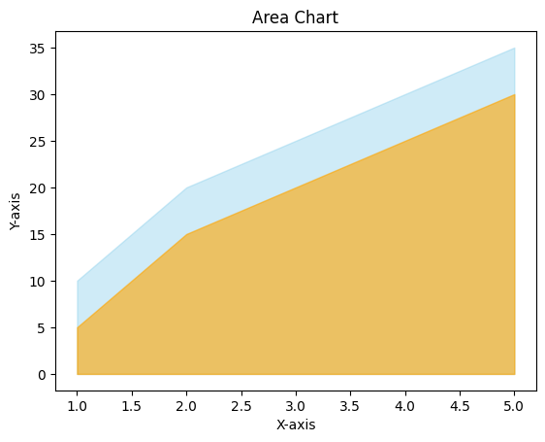

**13. Donut Chart**

import matplotlib.pyplot as plt

# Sample data

labels = ['A', 'B', 'C', 'D']

sizes = [15, 30, 45, 10]

# Create donut chart

plt.pie(sizes, labels=labels, autopct='%1.1f%%', startangle=90, pctdistance=0.85)

center_circle = plt.Circle((0, 0), 0.70, fc='white')

fig = plt.gcf()

fig.gca().add_artist(center_circle)

plt.title("Donut Chart")

plt.show()

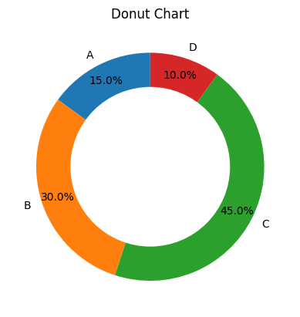

**14. Radar Chart**

import matplotlib.pyplot as plt

import numpy as np

# Sample data

labels = np.array(['A', 'B', 'C', 'D', 'E'])

values = np.array([4, 3, 2, 5, 4])

# Create radar chart

angles = np.linspace(0, 2 * np.pi, len(labels), endpoint=False).tolist()

values = np.concatenate((values, [values[0]]))

angles += angles[:1]

fig, ax = plt.subplots(figsize=(6, 6), subplot_kw=dict(polar=True))

ax.fill(angles, values, color='blue', alpha=0.25)

ax.plot(angles, values, color='blue', linewidth=2)

ax.set_yticklabels([])

ax.set_xticks(angles[:-1])

ax.set_xticklabels(labels)

plt.title("Radar Chart")

plt.show()

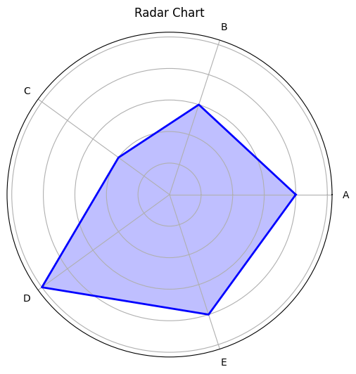

**15. Bubble Chart**

import matplotlib.pyplot as plt

# Sample data

x = [10, 20, 30, 40, 50]

y = [15, 25, 35, 45, 55]

sizes = [100, 200, 300, 400, 500]

# Create bubble chart

plt.scatter(x, y, s=sizes, alpha=0.5)

plt.title("Bubble Chart")

plt.xlabel("X-axis")

plt.ylabel("Y-axis")

plt.show()

These examples cover a wide range of common data visualizations. You can adjust the data and parameters to fit your specific needs. Each of these charts can be further customized with additional features, such as adding labels, changing colors, or adjusting the layout.